BATTLE AGAINST THE TRUSTS
The growth of trusts in the oil refining, steel making, and other industries created huge problems for Americans. Trusts forced other companies out of business by using unfair methods. One method was to lower prices until other companies could not compete. Then, when there was no competition, the trusts would raise prices as high as they pleased. The trusts used their massive wealth to influence and interfere with government. As a result, more and more Americans came to believe that it was time for government to act against the trusts. This was a subject that many American cartoonists, including Joseph Keppler, dealt with around the beginning of the 1900s.

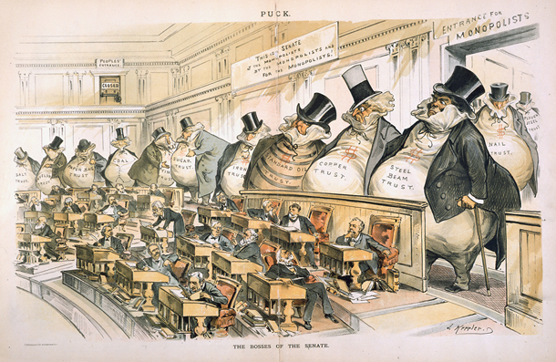
Examine the cartoon and answer the questions below:

1. What is the setting for this cartoon?
2. Who are the people in the front of the cartoon? Who are the people in the back row?
3. How does the cartoonist use size and caricature to make his point of view?
4. Turn your attention to the sign at the top center of the cartoon. What does this sign mean? To what famous document in American history does the sign refer? How does the cartoonist use the sign to make an ironic point about the
system of trusts?
“The Bosses of the Senate”

