Station 1:
Treaty of Versailles

Germany punished for starting WWI

Country | Name | What he wanted
France | Georges Clemenceau | Wanted revenge and make sure Germany could never start a war again
Britain | Lloyd George | Agreed with Wilson, but knew British citizens agreed with Clemenceau. Wanted to find compromise
USA | Woodrow Wilson | Wanted to bring peace to Europe, wanted to create a treaty based on his 14 points. 14 points are never ratified by the united states including the creation of the League of Nations

How will the Treaty of Versailles cause World War II?
Main terms of the Treaty:
War Guilt Clause - Germany should accept the blame for starting World War One
Reparations - Germany had to pay £6,600 million for the damage caused by the war
Disarmament - Germany was only allowed to have a small army and six naval ships. No tanks, no air force and no submarines were allowed. The Rhineland area was to be de-militarized.
Territorial Clauses - Land was taken away from Germany and given to other countries. Anschluss (union with Austria) was forbidden.

Germany is left to struggle and begin blaming the harsh terms of the treaty as the root of all their problems

Station 2:
The Policy of Appeasement

What is appeasement? Giving in to someone provided their demands are seen as reasonable

Summarize the arguments for & against appeasement:
FOR APPEASEMENT | AGAINST APPEASEMENT
- Hitler was only taking back land that had been lost by the treaty of Versailles  - Before 1939, public opinion was against war. Most people did not want to experience another war  - Britain did not have the resources to fight a war, appeasement gave them time needed to build up aircraft and weapons  - A stronger Germany would prevent communism from spreading west  - Britain needed allies  - Fear of bombing campaigns | - Can’t trust hitler  - Allowed Germany to build aircraft and weapon and grow too strong  - Hitler became overconfident and believed that no country could challenge him  - Appeasement policy made Britain and France look weak  - Increased the divide between Russia and the west. Making an alliance with Russia would have been a better option  - Giving land to Germany meant there was more territory to conquer when the war began

Station 3:
Hitler’s Actions

What Hitler Did | Date Achieved | How did Hitler Achieve this? | What did the Allies do?
Re-armament | 1933 | Build up army & navy in secret | Nothing… hoped a strong Germany would stop communism from being a threat to Europe
Reclaim the Rhineland | 1936 | Invaded area west of the Rhine. Hitler said German lands should be protected by German troops | Nothing… many thought it was reasonable for Germany to protect its own land
Make Alliances | 1936  1938 | Rome-Berlin Axis Pact Germany & Italy  Anti-Comitern Pact Germany & Japan  Anschluss- sent troops into Austria, held fixed election saying that 99% of Austrians wanted to join with Germany | Austria seeks help from Britain, Italy, France. Nothing is done because no one wants another war  Hitler promises this is the end of his expansion of Germany
Unite German speaking people | 1938 | Invaded Sudetenland region of Czechoslovakia because he claimed that the majority of people that lived there were German | Munich Agreement- Neville Chamberlain (PM of Britain) met with Hitler 3 times in September 1938.  The agreement stated that Hitler could have the Sudetenland region as long as he did invade the rest of Czechoslovakia  Chamberlain declared there would be “peace in our time” after Hitler signs the agreement
Invade European countries | 1939 | Hitler invades the rest of Czechoslovakia (march 1939)  September 1, 1939 Germany invades Poland  Hitler makes an agreement with Stalin (nonaggression pact) to divide Poland | Czechoslovakia asks for help from Britain & France but they are not ready to take military action against Germany.  Britain & France promise that if Hitler invaded Poland they would take military action  Britain & France declare war on Germany but do not send soldiers to Poland

Station 4:
Failure of the League of Nations

Four main reasons for its failure
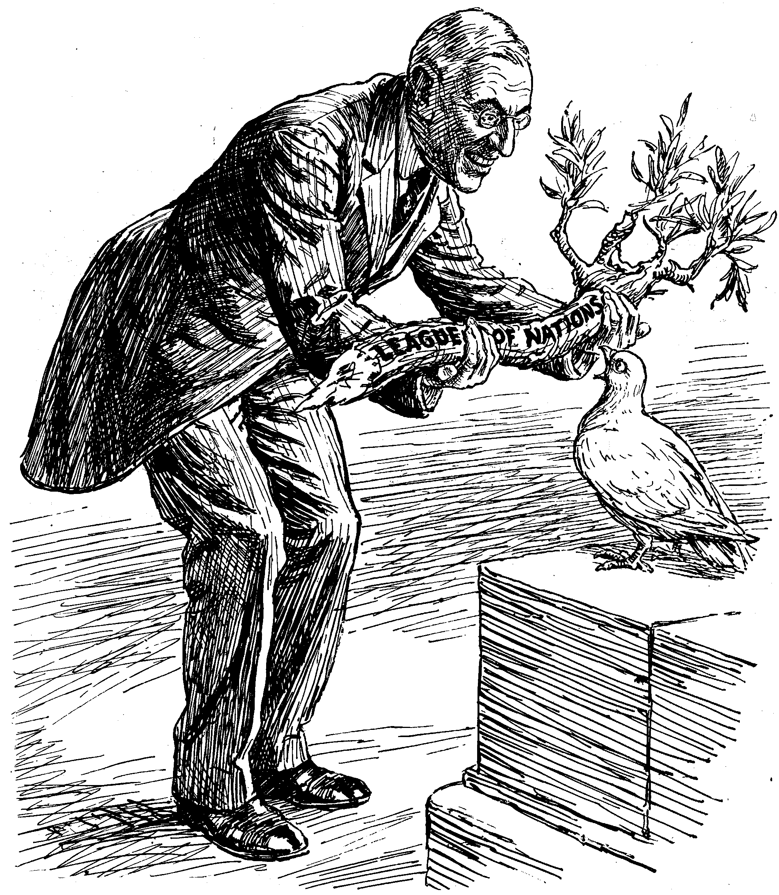
1. Not all countries joined- USA, Germany, Russia

2. The League had no power

3. No army

4. unable to act quickly

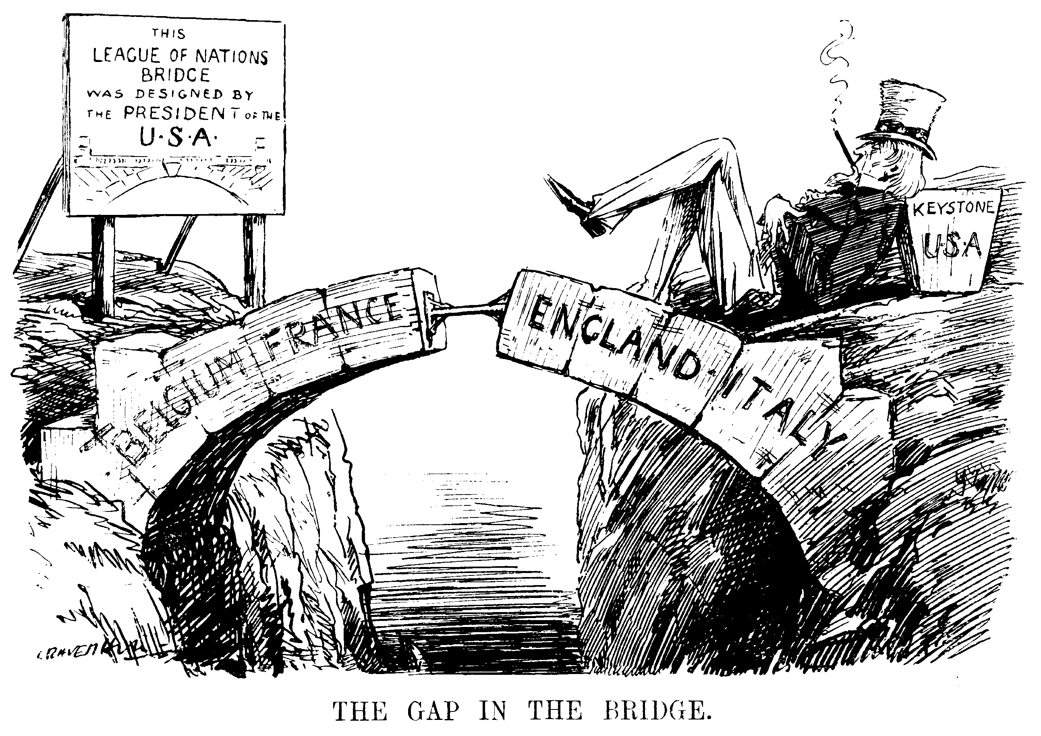
Explain how these cartoons helps us understand why the League of Nations failed.

Stations 5-8 Rise of the Dictators
Station 5: Read the overview and provide a summary of what you have read:

 | Station 6: Mussolini | Station 7: Hitler | Station 8: Tojo
What were the conditions of the dictator’s nations before he took power? | Was a constitutional monarchy  Economy was weak after WWI  High unemployment & inflation  Some farmers & workers want a Communist revolution |  | Japan wanted to create a colonial empire  Run by military nationalists  Tojo was a supporter of Hitler and wanted to have an alliance with Germany & Italy
How was the dictator able to come to power? | Speaking ability  Used his fascist party against those that wanted a Communist Revolution  Gained support from business & land owners  Sent his “Black Shirts” to Rome in October 1922 to defend the Italian government from the communist  King Victor Emmanuel III makes him the premier and head of government | Speaking ability  As the Nazi party rose to power so does Hitler  Becomes the country’s largest political party  Hitler comes to power legally by being appointed Chancellor/Prime Minister by the president | Moved up through the military  Appointed Japan’s minister of war  Appointed Prime minister in 1941
What evidence do you have that the dictator was NATIONALISTIC? | Made Italians believed that in order for Italy to be great again they must do exactly what he wanted | Used German pride  Blamed Jews & Communists for Germany’s problems | Believed the United States was lazy & incapable of being a strong united nation
What evidence do you have that the dictator was MILITARISTIC? | 1930s attacks Ethiopia  1939 attached & invades Albania |  | Authorized the attack on Pearl Harbor
What goals did the dictator have about territorial expansion? | Gained control of much of the Mediterranean region |  | Wanted to conquer other European countries but failed
What methods did they use to maintain their power? | Parades  Monuments  Controlled education  Fear | Fire that destroyed the parliament builded in blamed on communists  The president allows Hitler to take action against “Communist Menace” and begins taking rights away from Germans  Propaganda  Force storm troops, secret police  Controlled education  fear
What evidence is there that the dictator disrespected human rights?

