“The Ingenious Quarterback”

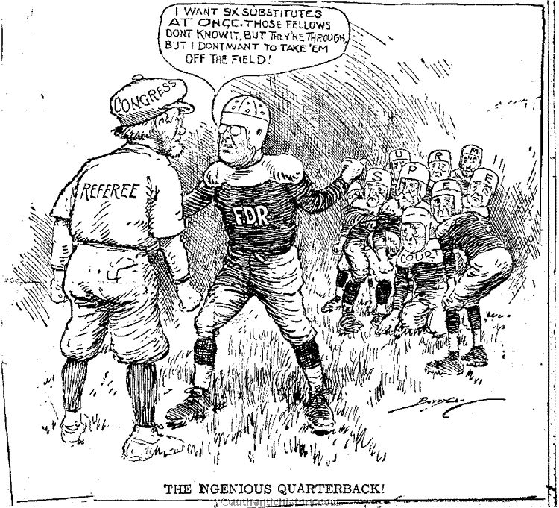

Historical Context: During President Franklin D. Roosevelt’s presidency, many parts of his “New Deal” social legislation was declared unconstitutional by the Supreme Court. Most of the justices had been placed on the Court by former Republican presidents. President Roosevelt proposed increasing the number of justices on the Supreme Court to counter the conservative justices. This event is often referred to as F.D.R.’s “Court-Packing Scandal.”

- Who does each person in the cartoon represent?
- What is the quarterback asking for? What does this mean FDR is asking for?
- According to the cartoon, who appears to have the authority to change the structure of the Supreme Court? Does F.D.R. have the authority to substitute players?
- What does the physical appearance of the football players reveal about the Supreme Court?
- How does F.D.R.’s comments reflect his urgency?
- The rules of football do not let teams substitute players without removing players that are already in the game. Knowing this, how do you think the cartoonist feels about what Roosevelt is trying to do?
- What does the title of the cartoon reveal about the situation?

