Immigration Bellwork

Examine both cartoons below answer the questions that follow.
1. What is the message of each cartoon?
2. What has happened between the first cartoon and the second cartoon that accounts for the difference in the portrayal and reception of the immigrants?
3. What predictions can you make about immigration during the Gilded Age?

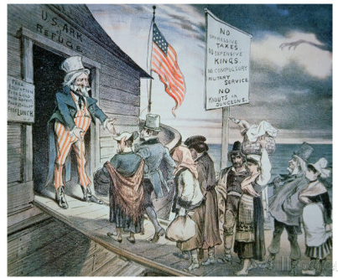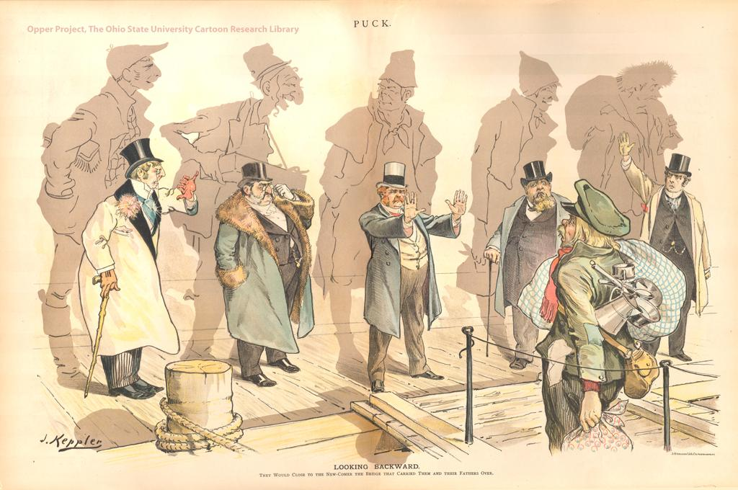
Early 1800s
Welcome to All!
1890
Looking Backward.
They would close to the newcomer the bridge that carried them and their fathers over.

