Imperialism & Progressive Era Retake assignment. A HARD COPY of this assignment is due by 3:05pm on Monday 12/2. ONLY HANDWRITTEN ASSIGNMENTS WILL BE ACCEPTED

Part 1: Create a study guide focusing on the presidents of this era and their major accomplishments

Roosevelt- Big Stick Diplomacy, Roosevelt Corollary, Square Deal, New Nationalism
Taft- Dollar Diplomacy
Spanish American War- causes & consequences
Wilson- Moral Diplomacy, New Freedom

Part 2:Complete the following activity.

America had fulfilled its Manifest Destiny. Now many Americans wanted to expand overseas. Businessmen wanted to profit from international trade. Politicians argued that the navy needed to establish overseas naval bases. Philosophers thought that America had a duty to export Anglo-Saxonism to “inferior” civilizations. The nation wrestled with the question of imperialism in the Caribbean, Latin America, the Pacific, and Asia.

DIRECTIONS: Identify which nation was involved in each event listed below. Write the numbers of the event next to the appropriate country or territory.

_____China
_____Cuba
_____Guam
_____Hawaii
_____Japan
_____Latin America
_____Panama
_____Philippines
_____Puerto Rico

1. This island was annexed as an “unincorporated territory” in the Foraker Act.
2. After warships under Commodore Perry’s command arrived, leaders signed a treaty opening two ports to American trade and began to Westernize this formerly closed country.
3. Britain signed exclusive canal rights over to the United States in the Hay-Pauncefote Treaty.
4. Sugar plantation owners requested annexation of this island in 1893.
5. The Boxer Rebellion, secretly supported by the government, sought to expel foreigners.
6. General MacArthur fought guerrilla resistance while Governor Taft introduced the reforms that ultimately reduced hostility to American rule.
7. “Remember the Maine” was the cry of the Rough Riders who overcame the Spanish defenders on San Juan Hill.
8. Revolutionary leader Emilio Aguinaldo initially supported the Americans after they won the first naval battle of the Spanish-American War here.
9. American intervention was advocated in the Roosevelt Corollary to the Monroe Doctrine.
10. Acquired from Spain in the Treaty of Paris, this island now serves as a military base.
11. Secretary Hay proposed an Open Door policy with this country’s leaseholders in order to keep the ports open to American trade.
12. Under the terms of the Platt Amendment, this country became an American protectorate until the amendment’s repeal in 1934.
13. President Taft promoted “dollar diplomacy” as favorable for mutual economic development.

Part 3 Study the Images and answer the questions that follow:

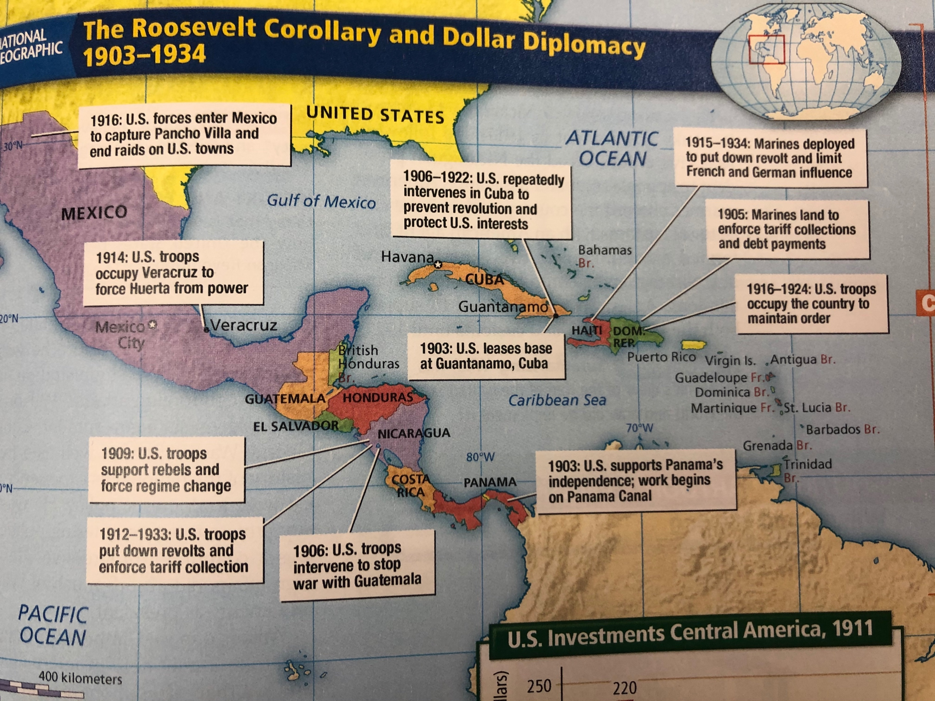

1. Based on the map, what are the main reasons the United States intervened in Latin American states?
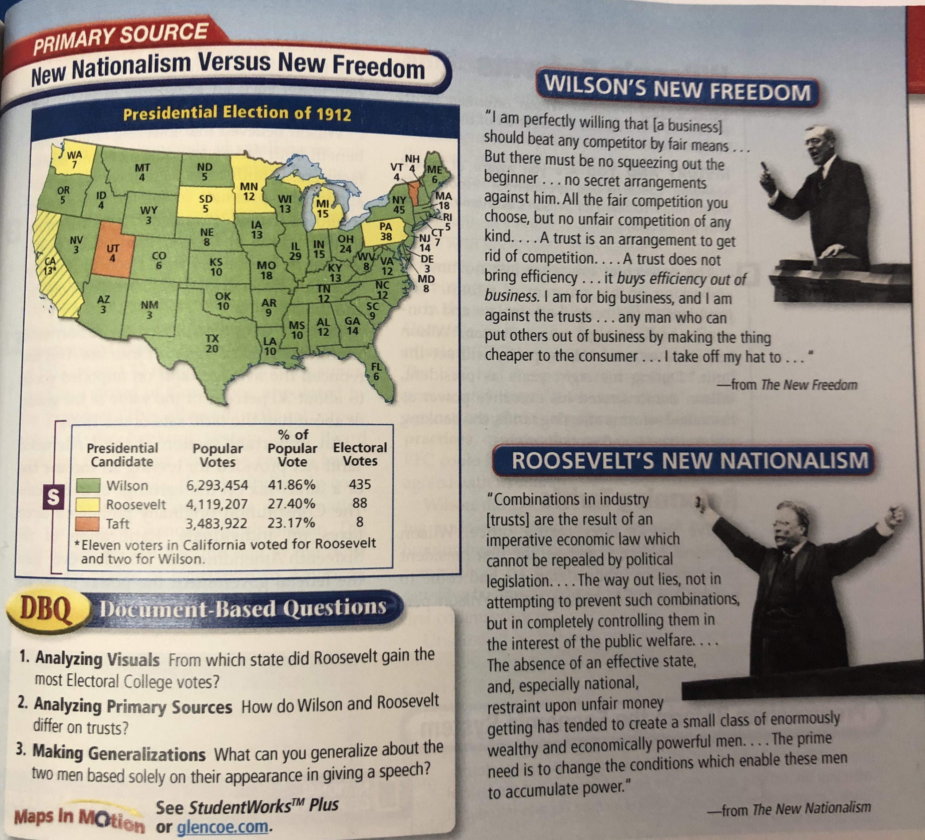

2. How do Wilson and Roosevelt differ on trusts?

Part 4 Textbook Questions

Complete the following Chapter Assessment Questions. Answers should be written in complete sentences.

Chapter 3 Becoming a World Power
#s 3-5, 7-9,11-13

Chapter 4 The Progressive Movement
#s1-9, 14

