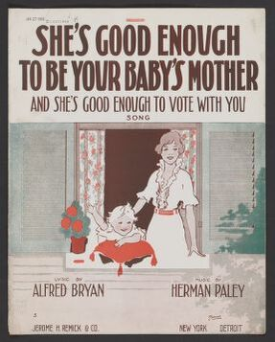 | “She’s Good Enough”  Is this cartoon FOR or AGAINST suffrage for women?  How do you know? List any images/ phrases/ etc. that helped you come to this conclusion?
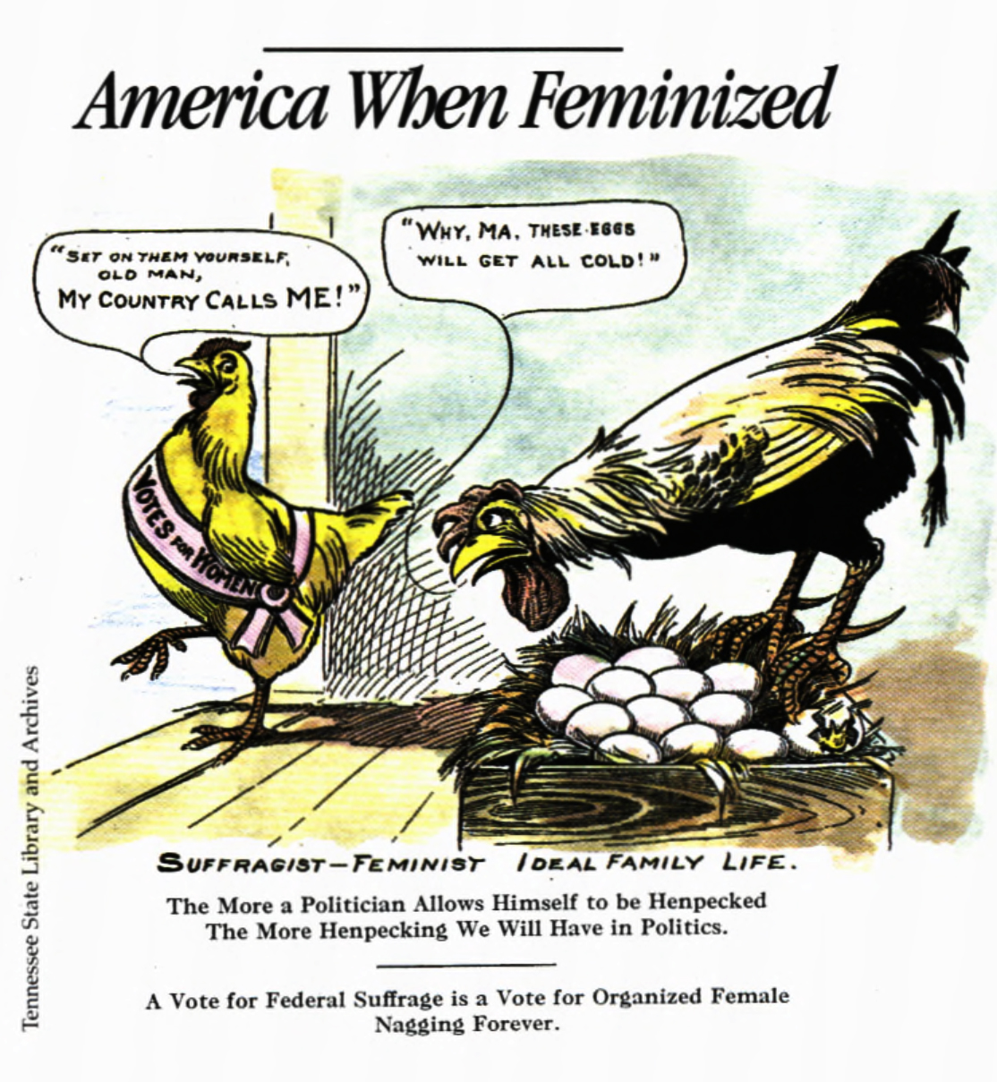 | “America When Feminized”  Is this cartoon FOR or AGAINST suffrage for women?  How do you know? List any images/ phrases/ etc. that helped you come to this conclusion?
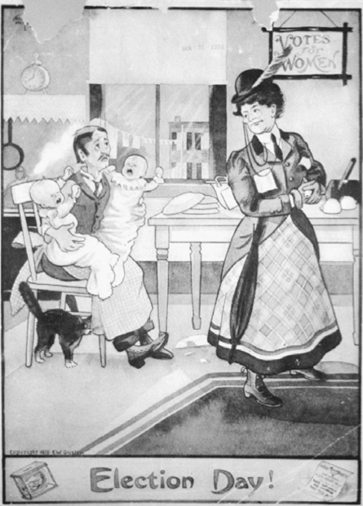 | “Election Day”  Is this cartoon FOR or AGAINST suffrage for women?  How do you know? List any images/ phrases/ etc. that helped you come to this conclusion?

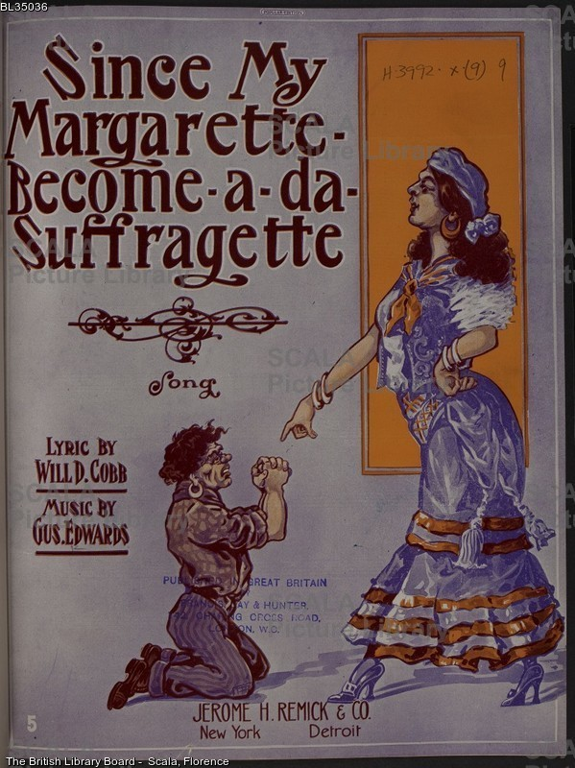 | “Margarette”  Is this cartoon FOR or AGAINST suffrage for women?  How do you know? List any images/ phrases/ etc. that helped you come to this conclusion?
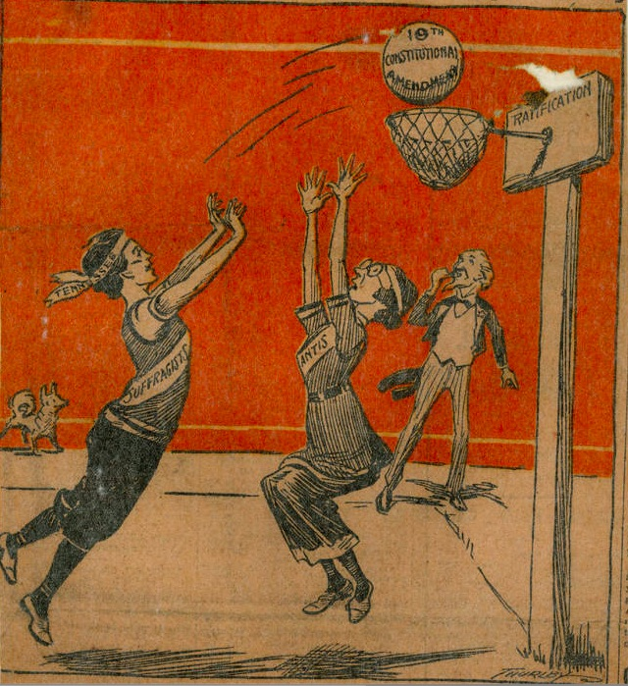 | “Goal”  Is this cartoon FOR or AGAINST suffrage for women?  How do you know? List any images/ phrases/ etc. that helped you come to this conclusion?
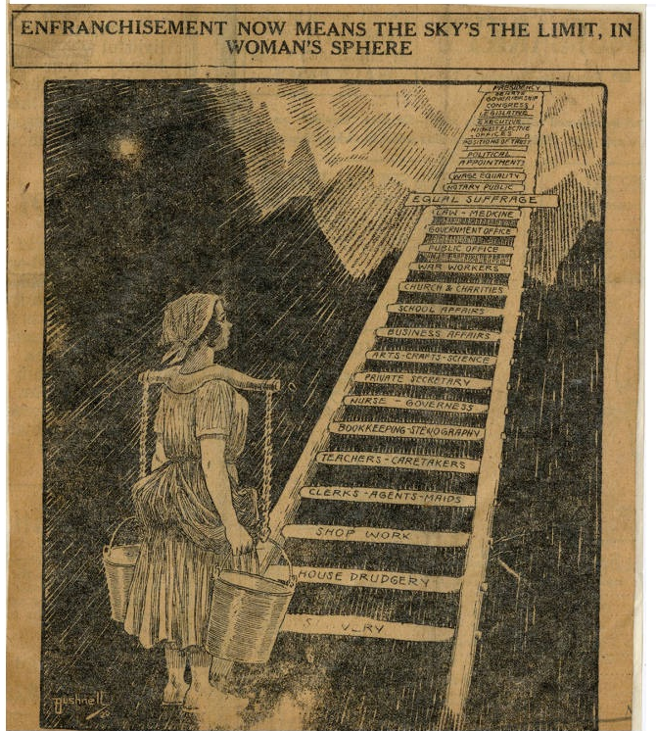 | “Sky’s the Limit”  Is this cartoon FOR or AGAINST suffrage for women?  How do you know? List any images/ phrases/ etc. that helped you come to this conclusion?
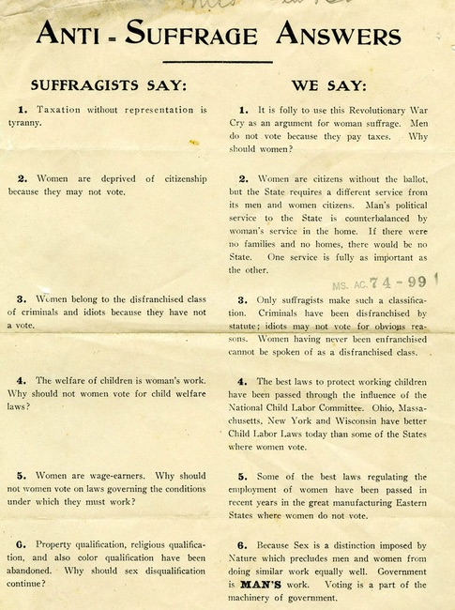 | “Answers”  Is this cartoon FOR or AGAINST suffrage for women?  How do you know? List any images/ phrases/ etc. that helped you come to this conclusion?
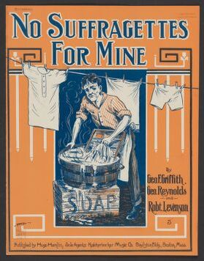 | “No Suffragettes”  Is this cartoon FOR or AGAINST suffrage for women?  How do you know? List any images/ phrases/ etc. that helped you come to this conclusion?
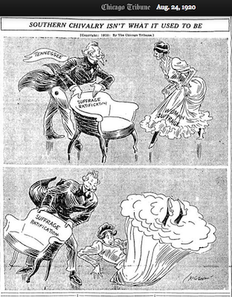 | “Southern Chivalry”  Is this cartoon FOR or AGAINST suffrage for women?  How do you know? List any images/ phrases/ etc. that helped you come to this conclusion?

