**STATION 1🡪 THE ASSASSINATION OF ARCHDUKE FRANZ FERDINAND**

Read the article on Franz Ferdinand. Complete boxes 1-2 on your comic strip.

**STATION 2🡪 MAIN CAUSES OF WORLD WAR I**

Read the article to complete the chart and questions below. Then complete boxes 3-6 on your comic strip.

|  |  |  |
| --- | --- | --- |
|  | **DEFINITION** | **EXAMPLE** |
| **M**ILITARISM | **The army and military forces are given a high profile by the government** | **Arms race between major European countries**  **France & Germany double their armies 1870-1914**  **Britain vs Germany for mastery of the seas (both created their own battleships**  **Germany made plans to attack France through Belgium if Russia attacked Germany** |
| **A**LLIANCES | **An agreement made between 2 or more countries to give each other help if needed** | **Triple Entente/ Allies : Britain, Russia, France**  **Triple Alliance/ Central Powers: Germany, Austria-Hungary,**  **Italy was originally allied with Germany and Austria-Hungary but stayed neutral once the war started they deiced to side with**  **When the war started they felt they would gain more by siding with the Allies** |
| **I**MPERIALISM | **When a country takes over new lands or countries and makes them subject to their rule** | **The British empire extended over 5 continents**  **France had control of large areas of Africa**  **Rivalry🡪 Germany only had small areas of Africa**  **When Britain gave Morocco to France Germany supported Morocco’s bid for independence** |
| **N**ATIONALISM | **Being a strong supporter of the rights and interests of one’s country** | **Reunification of Italy 1861**  **Reunification of Germany 1871**  **France angry because Germany was given land after the Franco-Prussian war**  **Austria-Hungary & Serbia were home to many natioanlists groups that wanted freedom** |

Summarize the Bosnian and Moroccan Crises.

**Morocco🡪 after France received Morocco from Britain. Moroccans wanted independence. The received support from Germany. In 1911 Germany was given part of the French Congo to avoid war**

**Bosnia🡪 1908 Austria-Hungary took over Bosnia and angered Serbia who felt it should be theirs.Germany & Austria-Hungary vs. Russia. War is avoided. Several other problems will arise between 1911-1912 that will leave tensions high between Serbia and Austria-Hungary.**

**STATION 3🡪 THEATRE OF WAR**

_**D**__ Western Front

A. To Torpedo Supply Ships

B. There were 12 battles along the river Isonzo in this location

C. This took Russia out of the war

D. Characterized by trench warfare, stretched from Belgium to Switzerland

E. Britain and Germany competed for “mastery of the seas”

F. Line of Fighting between Russia and Germany and Austria-Hungary

G. To keep German ships in German ports

H. The German army crossed the Belgian border

I. Many soldiers from Australia and New Zealand lost their lives on this peninsula

_**F**__ Eastern Front

_**B**__ Italian Front

_**I**__ Gallipoli

_**E**__ Naval Race

_**H**__ August 3, 1914

_**G**__ Britain’s Naval Tactic

_**A**__ Germany’s Naval Tactic

_**C**__ Brest Litovsk

**STATION 4🡪 LIFE IN THE TRENCHES**

Read the article. Imagine you are a soldier in World War I, write a short letter home describing life as a soldier and the conditions in the trenches. You must use at least 1 trench vocab word and describe 1 new weapon.

**Guns🡪Bolt action Rifle (main weapon used by the british) ; The first machine guns needed 4-6 men to work on them**

**Zeppelin🡪 also known as a blimp, used in the early part of the war in bombing raids by the germans, they were eventually abandoned because they could be shot down easily**

**Gas🡪 chlorine gas first used at the battle of Ypres in 1915. Causes its victims to suffocate. Mustard gas fired into the trenches in shells. Causes its blistering skin vomiting sore eyes external and internal bleeding and death can take up to 5 weeks**

**Tanks🡪 used for the first time in WWI. “Little Willie” had a crew of 3 with a max speed of 3mph and could not cross trenches. Later tanks could reach 4mph and hold 10 men**

**Planes🡪 used for the first time in WWI. Used to deliver bombs and spying. Later they later they were armed**

**Torpedoes🡪 used by submarines to blow up ships**





**STATION 5🡪 THE END OF THE WAR**

How was the United States involved in this war prior to declaring war on Germany? **Supplied its allies with weapons and supplies**

When does the United States join the war? **April 6, 1917**

What tactics were used to win the war? **Rapid advancements in weapons technology (tanks and planes), naval blockades**

When does the war end? **November 11, 1918**

**STATION 6🡪 TENNESSEE & WORLD WAR I**

Read through pages 34-37 in the TN History for Kids booklet. Answer the questions below.

* Who was Alvin York? What was his contribution to this war? **Alvin York originally objected to be drafted into the Army but later changed his mind. He is known for his service in the 1918 Battle of Argonne Forest where he led an attack on Germans. He killed 28 Germans, captured 132 others and took 32 machine guns. He was awarded the Medal of Honor. After the war, he refused to talk publicly about war because he believed it was wrong to profit from what he’d done.**
* What was the purpose of the Old Hickory plant? **Gunpowder plant build by the federal government in 1917. By November 1918 the factory was producing a million pounds a day.**

STATION 7🡪 THE TREATY OF VERSAILLES

|  |  |  |
| --- | --- | --- |
| **What did the Treaty of Versailles mean for Germany & Europe** | | |
|  | **Germany** | **Europe** |
| **War Guilt Clause** | **Had to accept blame for starting the war** |  |
| **Reparations** | **Had to pay $30 billion in damages** | **Austria 🡪 was to pay reparations but went rate could be set**  **Hungary🡪 was set to pay reparations but the amount was never set**  **Bulgaria🡪 had to pay reparations but eventually had their amount reduced by 75%** |
| **Military** | **Army reduced to 100,000 men and no tanks were allowed**  **Navy was only allowed 6 ships and no subs**  **Air force was taken away**  **The Rhineland are was to be kept free pf German military personnel and weapons (see map)** | **Austria 🡪 army reduced to 30,000 men**  **Hungary🡪 army reduced to 35,000**  **Bulgaria🡪 restrictions were made on the size of their army** |
| **Land** | **Anschluss- Germany not allowed to unite with Austria**  **Lost land to several other countries**  **The League of Nations took control of Germany’s colonies** | **Austria🡪 Anschluss- not allowed to unite with Germany. lost land to Italy, Czechoslovakia, and Serbia**  **Hungary🡪 lost land to Czecholsolvakia, Romania & Serbia. This causes a drastic drop in their land size as well as their population**  **Bulgaria🡪 lost land to Greece, Romania, and Yugoslavia**  **Turkey🡪 lost land to Greece and the League of nations took control of its colonies** |
| **Peace Keeping** | **Banned from League of Nations** |  |

Explain how this cartoon show’s Germany’s position in 1919.

**Germany had no choice but to accept the terms of the Treaty**

Who were the “big four” leaders? Did they agree on how to deal with Germany after the war?

**Lloyd George- England**

**Orlando- Italy**

**Clemenceau- France**

**Woodrow Wilson- United States**

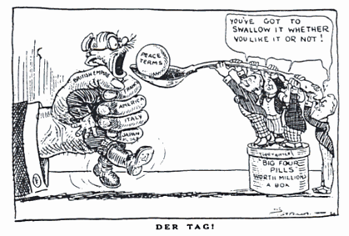

[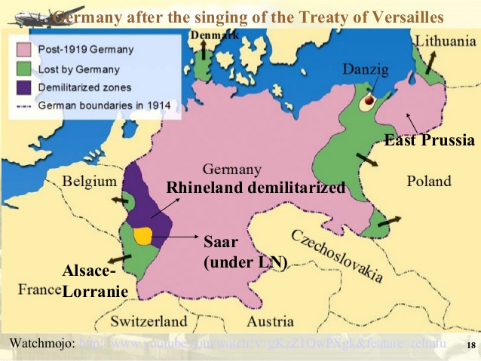](https://www.google.com/url?sa=i&rct=j&q=&esrc=s&source=images&cd=&cad=rja&uact=8&ved=2ahUKEwiW8OHtz8feAhWK0FMKHb1PD0oQjRx6BAgBEAU&url=https%3A%2F%2Fwww.slideshare.net%2FJoanieYeung%2Fparis-peace-conference-1919-treaty-of-versailles-33144408&psig=AOvVaw0P867YMyFuIisXwd8hLTt4&ust=1541863626130216)